# Status Usage Facts (2024 - 06)

Cara Frissell - June 2024

## Knowns

### Status definitions. The different statuses that a claim can have are documented and defined by BTSSS. Those definitions are available on the BTSSS site.

#### Saved or Incomplete

These are claims that the Beneficiary Travel office cannot process. Either you have not submitted the claim, or you submitted a claim without required information. This category of claim statues includes:

***Incomplete*** — You submitted a claim without required expense information. You must provide the required information for BTSSS to process the claim.

***Saved*** — You saved changes to your claim, but you did not submit it to BTSSS for review. Submit the claim so BTSSS can beginprocessing your claim.

#### Under VA Review

These claims require action from VA. If VA needs more information from you, your Travel Clerk will contact you.

***In Process*** — You submitted a claim, and now BTSSS is reviewing your claim.

***Claim Submitted*** — You submitted a claim for a completed appointment.

***In Manual Review*** — Your claim requires a manual review by a Travel Clerk due to one or more of the following reasons: Your claim includes receipts

* The mileage is not equal to or less than the calculated limit
* Your travel does not meet the eligibility requirements for detailed information about your claim, contact your local VAMC and ask for the Beneficiary Travel department.

***On Hold*** — You must provide the needed information for the claim to be processed. Your Travel Clerk will contact you when they put your claim on hold and tell you what additional information is required. For more information about your claim, please contact your local VAMC and ask for the Beneficiary Travel department.

***Appealed*** — You appealed the denial of your claim. The Travel Clerk will review your appeal.

#### Closed

The Beneficiary Travel office finished their review of your claim and closed it. In some situations you can appeal the BeneficiaryTravel department’s decision and re-open a claim. If you have questions about why your claim has one of the following statuses,contact your local VAMC and ask for the Beneficiary Travel department.

***Partial Payment*** — The Travel Clerk determined the claim does not qualify for a full reimbursement. Instead, they approved a partial payment and sent a Partial Payment letter was sent to you.

***Denied*** —The Travel Clerk denied your claim for one or more of the following reasons:Claims is not eligible for reimbursement

* The Travel Clerk could not verification the services in your claim
* Your appointment does not exist in VISTA, either because the VA clinic you went to did not enter it or you received care at a non-VAfacility
* The Travel Clerk sent you a denial letter. The letter contains information on how to appeal the decision.

***Closed with No Payment*** — The Travel Clerk determined the claim did not incur a cost and that no payment is necessary. The Travel Clerk will archive your claim.

***Approved for Payment*** — The Travel Clerk approved your claim for payment. The payment is pending and has not been paid.

***Submitted for Payment*** — The approved claim payment is assigned to the Financial Service Center (FSC) so that you can receive reimbursement.

***Fiscal Rescinded*** — The Financial Service Center (FSC) rejected payment. You will not be able to appeal this decision. For more detailed information about your claim, please contact your local VAMC and ask for the Beneficiary Travel department.

***Claim Paid*** — The reimbursement on the approved claim is paid to the submitter. Note that reimbursements for claims submitted by a Caregiver on behalf of a Veteran claimant are sent to the Caregiver’s address or deposited in the Caregiver’s account.

***Payment Canceled*** — The fund transfer did not complete because of the claimant’s bank. Payment has been canceled. You may create a new claim and reference the original claim number in the Notes section of the new claim.

### User (mis)comprehension. Many of those statuses do not make sense to users without further definition, [found in research](https://github.com/department-of-veterans-affairs/va.gov-team/blob/master/products/health-care/checkin/research/2023-11%20Past%20Appointments%20Travel%20Reimbursement%20Generative%20Usability%20Study/BTSSS_claim_status_exercise.md)

### Main claim endings. While there are many statuses, outside of of full approval and payment, there are [3 main “endings”](https://app.mural.co/t/departmentofveteransaffairs9999/m/departmentofveteransaffairs9999/1712673980094/648adf9a347a7618219b71f7923b48ffa09764f6?sender=ucbacbd1daef36939e8aa2288) for a claim:

##### Denied claim — Travel clerk sends denial letter

##### Partial payment - status becomes partial pay, partial pay letter letter sent to claimant

##### Resolves or overrides failed criteria and resubmits the claim - BTSSS TCM re-runs the rules engine if the Clerk resolves and overrides

### Frequently used statuses.

This analysis is based on the status of all Travel Claims submitted in May 2024 on June 3, 2024.

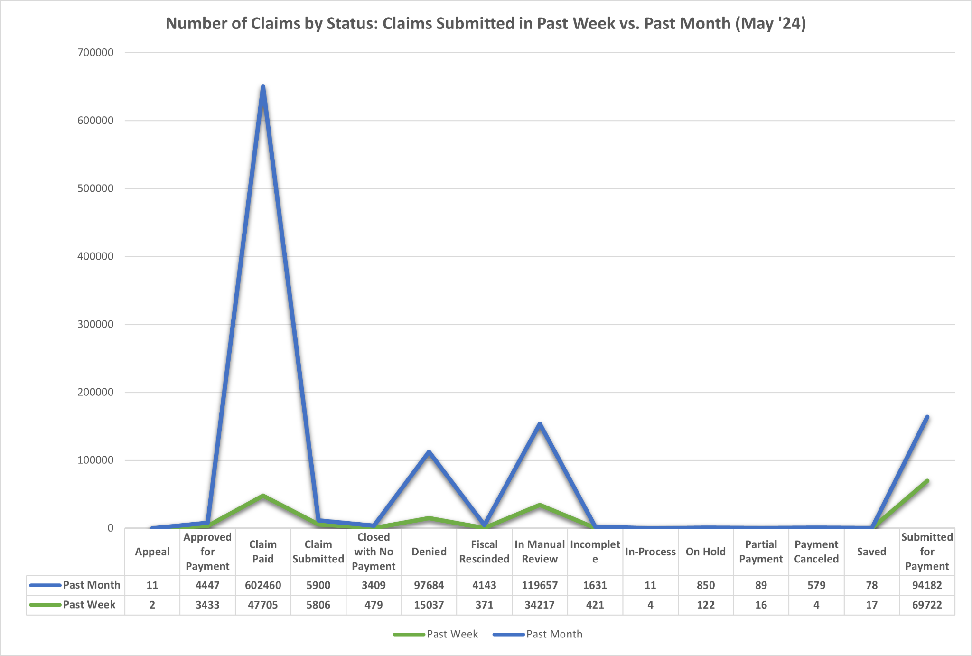

Week total = 177356

Month total = 935131

We can make an educated guess at the most commonly used statuses. These are the statuses a user is most likely to encounter.

* Claim paid
* Denied
* In Manual Review
* Submitted for Payment

We can make an educated guess at the statuses users are least likely to encounter:

* Appeal
* In-process
* Partial Payment
* Payment canceled